TCP通信协议
V1.0

Github:https://github.com/GoodTekken/qt_tcp_interface
目录
1， 简介 4
1.1 通信IP与通信端口 4
2， 通信协议介绍 5
2.1 Message_q定义 5
2.2 Message_b定义 6
2.3 Message_s定义 8
2.4 Message_n定义 9
2.5 Message_m定义 10
3，通信流程 12
3.1 正常订单流程 12
3.2 重定向订单流程 14
3.3 取消订单流程 16
3.4 取货失败处理流程 17
3.5 卸货失败处理流程 18
3.6 洗车处理流程 19
4，附录 20

历史版本
版本 | 日期 | 修订内容 | 作者
V1.0 | 2022/08/27 | 文档创建 | 吕凯盛

简介

1.1 通信IP与通信端口
PDS是以守护进程的方式直接运行在IFM O3D303相机上的，相机的默认IP是192.168.0.69，PDS系统监听55555端口，在应用层上，PDS是采用TCP通信协议进行通信的。全部的数据字节序都是大端（即网络所使用的字节序）
注:除非特别指明，否则本文使用的距离单位均为米，角度单位均为弧度，坐标系均为右手系，坐标原点为相机镜片中心
下一章，进入通信协议介绍。

通信协议介绍
以下是常用的4条通信协议：

报文类型 | 功能
NOOP | 无操作，可以用于确认是否连接（心跳）
GETPALLET | NDC对于订单状态的通知。
GetArray | NDC向Host请求或确认同步信息。
SaveReferenceForks | Host删除任务（根据索引或车辆ID）
GetRack | Host回复Message_s的信号。
VolCheck
GetConfig
SetConfig
SaveConfig
ResetConfig
SaveExtrinsics

2.1 NOOP定义
作用 | 无操作，可以用于确认是否连接（心跳）
格式 | Request:  Seq_start(‘star’),cmd_id(0),arg_len(0),seq_end(“stop\n\r”)  Response:  Seq_start(‘star’),cmd_id(0),status(0 正常,错误码位于附录), len(6),seq_end(“stop\n\r”)
备注 | 具体的数据类型位于下图

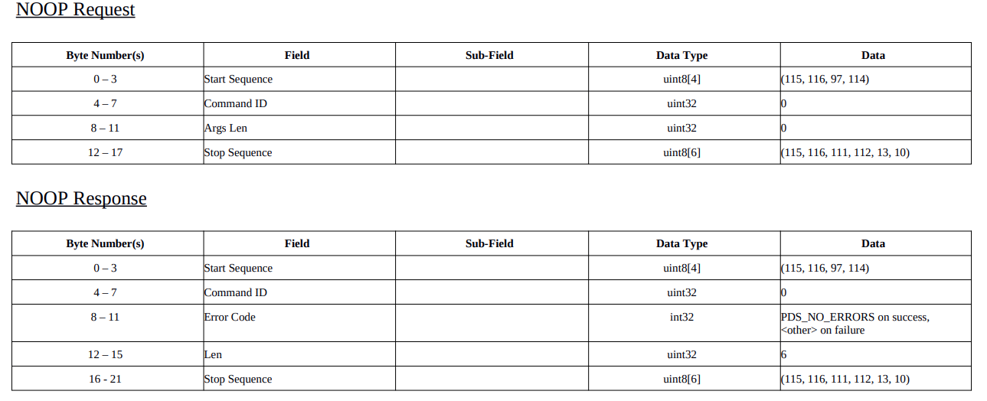

具体定义:未在手册上发现

2.2 GetPallet定义
作用 | 客户端向服务端获取托盘位置。服务端返回一个6自由度的托盘姿体
格式 | Request：  Seq_start,cmd_id(1),arg_len,pallet_type,depth_hint,filter_mask  Response:  Seq_start,cmd_id(1),status(附录),
备注 | 仅能识别2个洞口的托盘
Request:
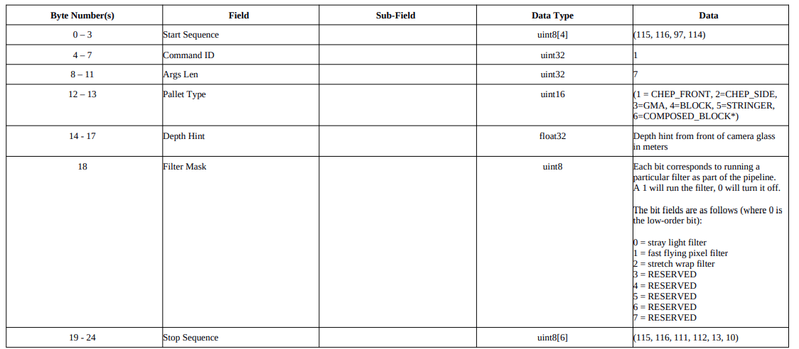
Response:
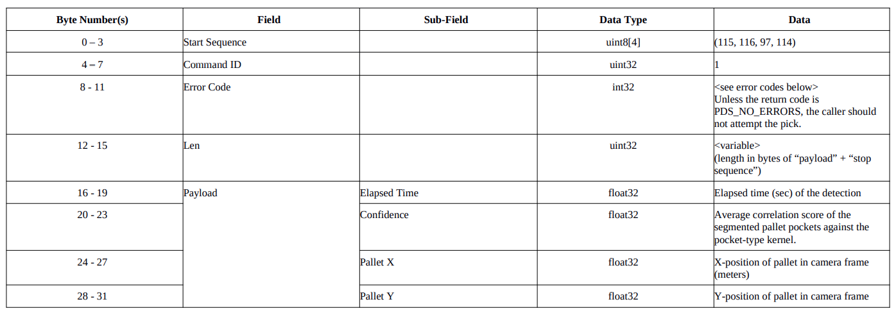
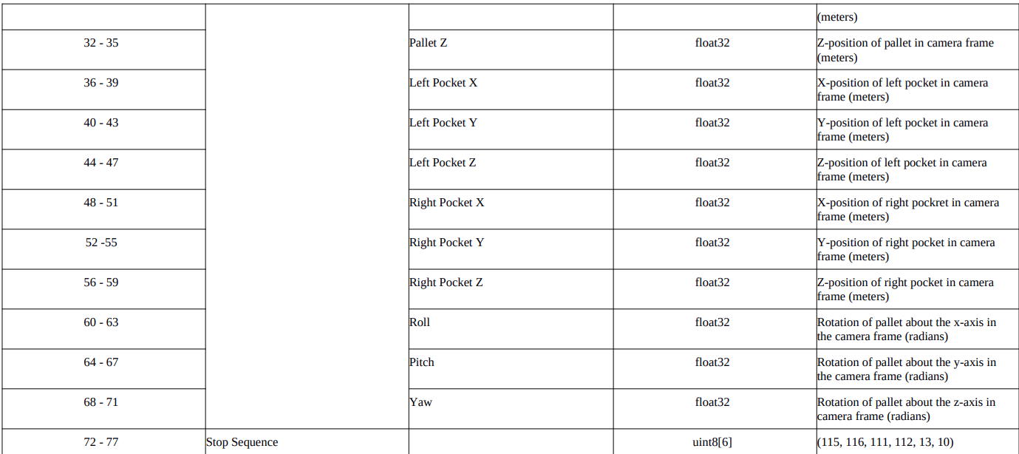

Value | Type | Status, by Value
0 | I | order rejected
1 | I | order acknowledge, input in queue
2 | VIII | allocation of carrier *
3 | IV | order finished
4 | II | order cancelled
5 | not implemented
6 | not implemented
7 | III | parameter acknowledge
8 | I | invalid number of parameters
9 | I | priority error
10 | I | invalid structure
10 | III | invalid structure
11 | I | order buffer full
12 | not implemented
13 | not implemented
14 | II | not activated index
14 | III | not activated index
15 | I | parameter number too high for this
15 | II | parameter number too high for this
15 | III | parameter number too high for this
16 | I | not allowed to update
16 | III | not allowed to update
17 | VI | fatal error, order execution stopped
18 | III | parameter deleted
19 | V | parameter value accepted
20 | V | parameter value not accepted
21 | VIII | order has lost the carrier *
22 | II | carrier number error
23 | V | input release
24 | II | invalid index number
24 | III | invalid index number
25 | II | cancel acknowledge
26 | I | missing parameters
27 | I | duplicated IKEY
28 | I | invalid format code
35 | VII | change order instance priority acknowledge
37 | VIII | connection of carrier – order *
39 | VIII | CONNECT OK, poffs=AGV id
40 | VIII | CONNECT failed, poffs=AGV id

2.3 Message_s定义
作用 | NDC主动向Host请求下一步指令。  如：NDC此时主动回复订单信息，主要包含Magic1,Magic2,Magic3。
格式 | Message:  s, index, trp str, order status, magic, magic_2, car no, spare, car stat, car stn, [ [ magic_3] [no_of_lp, lp[0] …. lp[n] ] ]
备注 | 通常情况下，Magic1一般赋值为phase(阶段值)。  Magic1是由NDC发送给Host的Message_S，作用在于通知Host了解和监控订单的状态。

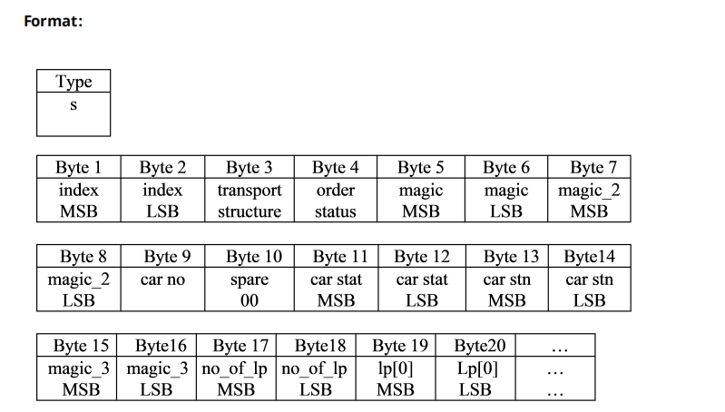

具体定义：
Magic1（16进制） | Description | 描述
0001 | Order start. | 订单开始。
0002 | Parameter acknowledge. | 参数确认。
0003 | Vehicle assigned to order. | 接受任务的指派车辆。
0004 | Vehicle arrived at load station. | AGV到达取货站点入口。
0006 | Loading completed. | AGV取货完成。
0008 | Vehicle arrived at unload station. | AGV到达卸货站点入口。
000A | Unloading completed. | AGV卸货完成。
000B | Order termination. | 订单完成。
0020 | Carwash found a loaded vehicle. | 发现需要洗车的AGV。
0021 | Move error for fetch operation. | 取货操作失败。
0022 | Move error for deliver operation. | 卸货操作失败。
0030 | Cancel request from System Manager. | NDC发送取消任务请求。
0031 | Invalid fetch station. | 无效的取货站点
0032 | Invalid deliver station. | 无效的卸货站点
6001 | System has performed a warm start. | 系统热启动。
6002 | System has performed a cold start | 系统冷启动。

2.4 Message_n定义
作用 | Host删除订单指令。
格式 | Message:  (a): n, index  (b): n, 0000, car no
备注 | 两种删除方式：1，根据任务索引index进行删除；2，根据车辆ID进行删除。

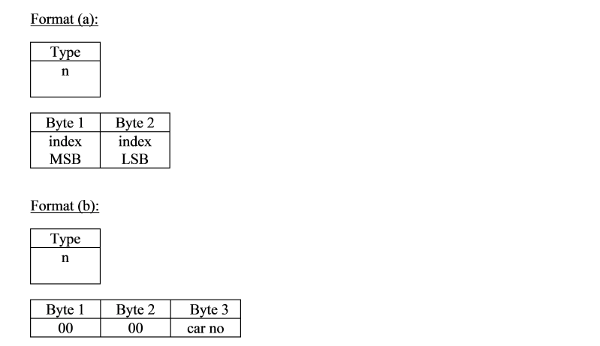

2.5 Message_m定义
作用 | Host对于NDC发送过来的Message_s进行回复。  如：Host使用Message_m对订单本地参数插入或者删除，以达到回复的效果。
格式 | Message:  m , index, function, par no, p0 val, [p[1] p[31] ]
备注 | function: 00,01：插入本地参数，02：删除本地参数，03：查询本地参数。  par no：参数索引，demo所定义的位置是18；

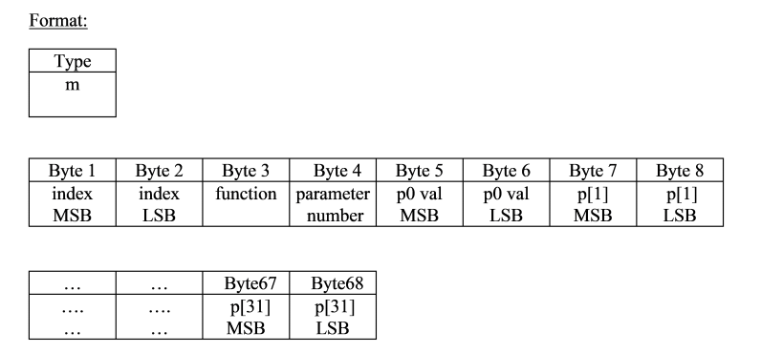

通信 | Magic1 | Maagic2 | Magic3 | 备注
NDC->HOST | 1 | 0 | IKEY | (PHASE,NULL,IKEY),订单开始。
HOST->NDC | 1 | - | - | (PHASE)
NDC->HOST | 2 | 1001 | 2001 | (PHASE，Fetch,Deliver),参数确认。
HOST->NDC | 2 | - | - | （PHASE）
NDC->HOST | 3 | Car ID | IKEY | (PHASE，Car ID,IKEY),分配车辆，前往取货点。
HOST->NDC | 3 | - | - | (PHASE)
NDC->HOST | 4 | 0 | IKEY | (PHASE,NULL,IKEY),到取货入口请求取货数。
HOST->NDC | 4 | ◎ | ◎ | (PHASE,取货高度，取货距离)
NDC->HOST | 5 | 2 | IKEY | (PHASE，Car ID,IKEY)，前往取货。
HOST->NDC | - | - | - | 不用回复。
NDC->HOST | 6 | 0 | IKEY | (PHASE,NULL,IKEY)，取货完成。
HOST->NDC | 6 | - | - | (PHASE)
NDC->HOST | 8 | 0 | IKEY | (PHASE,NULL,IKEY)，到卸货入口请求卸货数。
HOST->NDC | 8 | ◎ | ◎ | (PHASE，卸货高度，卸货距离)
NDC->HOST | 10 | 0 | IKEY | (PHASE,NULL,IKEY),卸货完成。
HOST->NDC | 10 | - | - | (PHASE)
NDC->HOST | 11 | 0 | IKEY | (PHASE,NULL,IKEY),订单完成
HOST->NDC | 11 | - | - | (PHASE)
NDC->HOST | 49 | Station | IKEY | (PHASE，Station,IKEY)（0X31）无效取货站点。
HOST->NDC | 143 | - | - | 取消订单（0X8F）
NDC->HOST | 50 | Station | IKEY | (PHASE，Station,IKEY)（0X32）无效卸货站点。
HOST->NDC | 143 | - | - | 取消订单(0X8F)
NDC->HOST | 30 | 0 | IKEY | (PHASE,Null,IKEY)，取消任务请求。
HOST->NDC | 30 | - | - | (PHASE)
NDC->HOST | 32 | 0 | IKEY | (PHASE,Null,IKEY)生成洗车任务请求卸货点。
HOST->NDC | 142 | Station | - | (PHASE，Station)发送卸货站点。
NDC->HOST | 48 | 0 | IKEY | (PHASE,Null,IKEY)生成洗车任务请求卸货点。
HOST->NDC | 143 | - | - | (PHASE),
NDC->HOST | 254 | Station | IKEY | (PHASE，Station,IKEY)确认卸货站点。  功能码：0XFE = 254。
HOST->NDC | 254 | - | - | (PHASE)
NDC->HOST | 255 | 0 | IKEY | (PHASE,Null,IKEY)确认取消任务。  功能码：0XFF = 255。
HOST->NDC | 255 | - | - | (PHASE)

3，通信流程

3.1 正常订单流程
定义： | 按照车辆的阶段值Phase正常顺序往下执行。

Host -> NDC |  | NDC -> Host
Message_q | 订单开始，包括优先级,IKEY,取货站点,卸货站点；  {00:00:00;2; 5;1001;2001;0; }
 |  | Message_b | 订单接收,返回订单索引index；  Status:1
 |  | Message_s | 系统同步：同步(phase, 0,ikey)  (1,0,8)订单开始
Message_m | 回复Message_s,同步(phase,null,null)-->(1,0,0)  (func,index,parno) -->(1,11,18)
 |  | Message_s | 系统同步：同步(phase, fetch station,deliver station)  (2,1001,2001)参数确认
Message_m | 回复Message_s,同步(phase,null,null)-->(2,0,0)  (func,index,parno) -->(1,11,18)
 |  | Message_s | 系统同步：同步(phase, Car ID,ikey)  (3,2,8)车辆分配
Message_m | 回复Message_s,同步(phase,null,null)-->(3,0,0)  (func,index,parno) -->(1,11,18)
 |  | Message_s | 系统同步：同步(phase,null,ikey)  (4,0,8)取货同步。  Host可回复取货高度等信息
Message_m | 回复Message_s,同步(phase,null,null)-->(4,0,0)  (func,index,parno) -->(1,11,18)
 |  | Message_s | 系统同步：同步(phase, Car ID,ikey)  (5,2,8)
 |  | Message_s | 系统同步：同步(phase,null,ikey)  (6,0,8)取货完成
Message_m | 回复Message_s,同步(phase,null,null)-->(6,0,0)  (func,index,parno) -->(1,11,18)
 |  | Message_s | 系统同步：同步(phase,null,ikey)  (8,0,8)卸货同步。  Host可回复卸货高度等信息
Message_m | 回复Message_s,同步(phase,null,null)-->(8,0,0)  (func,index,parno) -->(1,11,18)
 |  | Message_s | 系统同步：同步(phase,null,ikey)  (10,0,8)卸货完成
Message_m | 回复Message_s,同步(phase,null,null)-->(10,0,0)  (func,index,parno) -->(1,11,18)
 |  | Message_s | 系统同步：同步(phase,null,ikey)  (11,0,8)订单完成
Message_m | 回复Message_s,同步(phase,null,null)-->(11,0,0)  (func,index,parno) -->(1,11,18)
 |  | Message_b | 订单完成,返回订单索引index；Status:3，par no = FF

3.2 重定向订单流程
定义： | 在AGV进行取货或卸货进入站点前，可以重新更改AGV的  取货站点和卸货站点。

Host -> NDC |  | NDC -> Host
Message_q | 订单开始，包括优先级,IKEY,取货点,卸货点；  {00:00:00;2;5;1001;2001;0; }
 |  | Message_b | 系统通知：订单接收,返回订单索引index；  Status:1
 |  | Message_s | 系统同步：同步(phase, 0,ikey)  (1,0,8)订单开始
Message_m | 回复Message_s,  同步(phase,null,null)-->(1,0,0)  (func,index,parno) -->(1,11,18)
 |  | Message_s | 系统同步：同步(phase, fetch station,deliver station)  (2,1001,2001)参数确认
Message_m | 回复Message_s,  同步(phase,null,null)-->(2,0,0)  (func,index,parno) -->(1,11,18)
 |  | Message_s | 系统同步：同步(phase, Car ID,ikey)  (3,2,8)车辆分配
Message_m | 回复Message_s,  同步(phase,null,null)-->(3,0,0)  (func,index,parno) -->(1,11,18)
 |  | Message_s | 系统同步：同步(phase,fetch station ,ikey)  254,1003,8)车辆分配
Message_m | 回复Message_s,  同步(phase,null,null)-->(254,0,0)  (func,index,parno) -->(1,11,18)
 |  | Message_s | 系统同步：同步(phase, Car ID,ikey)  (3,2,8)获取点已更换
Message_s | 系统同步：同步(phase, Car ID,ikey)  (3,2,8)获取点已更换
 |  | ......
...... |  | Message_s | 系统同步：同步(phase,fetch station ,ikey)  254,2003,8)车辆分配
Message_m | 回复Message_s,  同步(phase,null,null)-->(254,0,0)  (func,index,parno) -->(1,11,18)
 |  | Message_s | 系统同步：同步(phase,null,ikey)  (8,0,8)卸货同步，Host可回复卸货高度等
回复Message_s,
同步(phase,null,null)-->(8,0,0)
(func,index,parno) -->(1,11,18)
 |  | ......
......

3.3 取消订单流程
定义： | 在AGV任务执行过程中，取消订单。

Host -> NDC |  | NDC -> Host
Message_q | 订单开始，包括优先级,IKEY,取货点,卸货点；  {00:00:00;2;5;1001;2001;0; }
 |  | Message_b | 系统通知：订单接收,返回订单索引index；  Status:1
 |  | Message_s | 系统同步：同步(phase, 0,ikey)  (1,0,8)订单开始
Message_m | 回复Message_s,  同步(phase,null,null)-->(1,0,0)  (func,index,parno) -->(1,11,18)
 |  | Message_s | 系统同步：  同步(phase, fetch station,deliver station)  (2,1001,2001)参数确认
Message_m | 回复Message_s,  同步(phase,null,null)-->(2,0,0)  (func,index,parno) -->(1,11,18)
 |  | Message_b | 系统通知，订单分配车辆；  Status:2
Message_m | (二选一)  回复取消指令，magic1:0x8F，同步时生效
Message_n | (二选一)直接取消
 |  | Message_b | 系统通知：订单取消；  Status:25
 |  | Message_s | 系统同步：NDC发送取消请求(phase, 0,ikey)  (48,0,8)发送取消请求
Message_m | 回复Message_s,  同意取消(phase,null,null)-->(143,0,0)  (func,index,parno) -->(1,11,18)
 |  | Message_s | 系统同步：NDC发送取消指令(phase, 0,ikey)  (255,0,8)发送取消指令
Message_m | 回复Message_s,  确定取消(phase,null,null)-->(255,0,0)  (func,index,parno) -->(1,11,18)
 |  | Message_s | 系统同步：订单完成(phase, 0,ikey)  (11,0,8)
Message_m | 回复Message_s,  订单完成(phase,null,null)-->(11,0,0)  (func,index,parno) -->(1,11,18)
 |  | Message_b | 系统通知：订单完成；  Status:3

3.4 取货失败处理流程
定义： | 在AGV取货过程中，AGV报告错误，此时取消当前任务。

Host -> NDC |  | NDC -> Host
 |  | Message_s | 系统同步：同步(phase, fetch station,0)  (0x21,station,0) 报告错误
Message_m | 回复Message_s,  同步(phase,null,null)-->(8F,0,0)  (func,index,parno) -->(1,11,18)取消订单
 |  | Message_s | 系统同步：同步(cancel,fetch station,ikey)  (0xFF,station,ikey)取消通知
Message_m | 回复Message_s,  同步(phase,null,null)-->(FF,0,0)  (func,index,parno) -->(1,11,18)
 |  | Message_s | 系统同步：同步(phase,null,ikey)  (11,0,ikey)订单完成
Message_m | 回复Message_s,  同步(phase,null,null)-->(11,0,0)  (func,index,parno) -->(1,11,18)
 |  | Message_b | 系统通知：订单完成,返回订单索引index；  Status:3，par no = FF

3.5 卸货失败处理流程
定义： | 在AGV卸货过程中，AGV报告错误，此时取消当前任务。

Host -> NDC |  | NDC -> Host
 |  | Message_s | 系统同步：  同步(phase, fetch station,0)  (0x22,station,0) 报告错误
Message_m | 回复Message_s,  同步(phase,null,null)-->(8F,0,0)  (func,index,parno) -->(1,11,18)取消订单
 |  | Message_s | 系统同步：同步(cancel,null,ikey)  (0xFF,0,ikey)取消通知
Message_m | 回复Message_s,  同步(phase,null,null)-->(FF,0,0)  (func,index,parno) -->(1,11,18)
 |  | Message_s | 系统同步：同步(phase,null,ikey)  (11,0,ikey)订单完成
Message_m | 回复Message_s,  同步(phase,null,null)-->(11,0,0)  (func,index,parno) -->(1,11,18)
 |  | Message_b | 系统通知：订单完成,返回订单索引index；Status:3，par no = FF
注意：此时任务订单取消以后，会由系统产生一个洗车任务；

3.6 洗车处理流程
定义： | 在AGV插入系统时，或取消订单后，如果发现AGV装载货  物，则要求系统分配一个卸货站点进行卸货。

Host -> NDC |  | NDC -> Host
 |  | Message_s | 系统同步：同步(phase, 0,ikey)  (0x20,0,8) 洗车通知
Message_m | 回复Message_s,  (phase,station,null)-->(142,1009,0)  (func,index,parno) -->(1,11,18)
 |  | Message_s | 系统同步：同步(phase, station,ikey)  (0xFE,0,8) NDC发送254，确认修改的卸货站点。
Message_m | 回复Message_s,  (phase,null,null)-->(254,0,0)  (func,index,parno) -->(1,11,18)
 |  | Message_s | 系统同步：同步(phase,null,ikey)  (8,0,8)卸货同步，Host可回复卸货高度等
Message_m | 回复Message_s,  同步(phase,null,null)-->(8,0,0)  (func,index,parno) -->(1,11,18)
 |  | Message_s | 系统同步：同步(phase,null,ikey)  (10,0,8)卸货完成
Message_m | 回复Message_s,  同步(phase,null,null)-->(10,0,0)  (func,index,parno) -->(1,11,18)
 |  | Message_s | 系统同步：同步(phase,null,ikey)  (11,0,8)订单完成
Message_m | 回复Message_s,  同步(phase,null,null)-->(11,0,0)  (func,index,parno) -->(1,11,18)
 |  | Message_b | 系统通知：订单完成,返回订单索引index；Status:3，par no = FF

4，附录
1.正常订单流程 | 备注
11:51:46: [Host->NDC] [message_q] Started Orders with IKEY/s 8  11:51:46: [Index 17] [NDC->Host] [message_b] 1.Order started, IKEY: 8  11:51:46: [Index 17] [NDC->Host] [message_s] Order Start, Phase: 1  11:51:46: [Index 17] [Host->NDC] [message_m] Sync Accepted,phase 1  11:51:48: [Index 17] [NDC->Host] [message_s] Fetch: 1001, Deliver: 2001, Phase: 2  11:51:48: [Index 17] [Host->NDC] [message_m] Sync Accepted,phase 2  11:51:49: [Index 17] [NDC->Host] [message_b] 2.Vehicle 2 allocated  11:52:44: [Index 17] [NDC->Host] [message_b] 37.Vehicle 2 connected  11:52:44: [Index 17] [NDC->Host] [message_s] Move to load, Phase: 3  11:52:44: [Index 17] [Host->NDC] [message_m] Sync Accepted,phase 3  11:52:44: [Index 17] [NDC->Host] [message_s] Load host sync, Phase: 4  11:52:44: [Index 17] [Host->NDC] [message_m] Sync Accepted,phase 4  11:52:45: [Index 17] [NDC->Host] [message_s] Load host sync, Phase: 4  11:52:45: [Index 17] [Host->NDC] [message_m] Sync Accepted,phase 4  11:52:46: [Index 17] [NDC->Host] [message_s] Loading...  11:53:17: [Index 17] [NDC->Host] [message_s] Loaded host sync, station: 1001, Phase: 6  11:53:17: [Index 17] [Host->NDC] [message_m] Sync Accepted,phase 6  11:54:05: [Index 17] [NDC->Host] [message_s] Unload host sync, Phase: 8  11:54:05: [Index 17] [Host->NDC] [message_m] Sync Accepted,phase 8  11:54:34: [Index 17] [NDC->Host] [message_s] Unloaded host sync, station: 2001, Phase: 10  11:54:34: [Index 17] [Host->NDC] [message_m] Sync Accepted,phase 10  11:54:34: [Index 17] [NDC->Host] [message_s] Order Finished, IKEY: 8  11:54:34: [Index 17] [Host->NDC] [message_m] Sync Accepted,phase 11  11:54:34: [Index 17] [NDC->Host] [message_b] 3.Order finished | Host 发起任务。  同步phase1。  同步phase2。  同步phase3。  同步phase4。（可增加取货高度和取货站点距离）  同步phase4。（可增加取货高度和取货站点距离）  同步 phase6。  同步phase8. （可增加取货高度和取货站点距离）  同步phase10。  同步phase11。

2.重定向订单流程 | 备注
11:59:02: [Host->NDC] [message_q] Started Orders with IKEY/s 8  11:59:02: [Index 18] [NDC->Host] [message_b] 1.Order started, IKEY: 8  11:59:02: [Index 18] [NDC->Host] [message_s] Order Start, Phase: 1  11:59:02: [Index 18] [Host->NDC] [message_m] Sync Accepted,phase 1  11:59:03: [Index 18] [NDC->Host] [message_s] Fetch: 1001, Deliver: 2001, Phase: 2  11:59:03: [Index 18] [Host->NDC] [message_m] Sync Accepted,phase 2  11:59:03: [Index 18] [NDC->Host] [message_b] 2.Vehicle 2 allocated  11:59:44: [Index 18][Host->NDC] [message_m] Redirect sent, station: 1002, function code: 1, phase: 142  12:01:13: [Index 18] [NDC->Host] [message_b] 37.Vehicle 2 connected  12:01:13: [Index 18] [NDC->Host] [message_s] Move to load, Phase: 3  12:01:13: [Index 18] [Host->NDC] [message_m] Sync Accepted,phase 3  12:01:13: [Index 18] [NDC->Host] [message_s] Redirecting Vehicle to stn: 1002, Phase: 254  12:01:13: [Index 18] [Host->NDC] [message_m] Sync Accepted,phase 254  12:01:14: [Index 18] [NDC->Host] [message_s] Move to load, Phase: 3  12:01:14: [Index 18] [Host->NDC] [message_m] Sync Accepted,phase 3  12:01:55: [Index 18] [NDC->Host] [message_s] Load host sync, Phase: 4  12:01:55: [Index 18] [Host->NDC] [message_m] Sync Accepted,phase 4  12:01:56: [Index 18] [NDC->Host] [message_s] Loading...  12:02:29: [Index 18] [NDC->Host] [message_s] Loaded host sync, station: 1002, Phase: 6  12:02:29: [Index 18] [Host->NDC] [message_m] Sync Accepted,phase 6  12:02:46: [Index 18][Host->NDC] [message_m] Redirect sent, station: 2002, function code: 1, phase: 142  12:02:46: [Index 18] [NDC->Host] [message_s] Redirecting Vehicle to stn: 2002, Phase: 254  12:02:46: [Index 18] [Host->NDC] [message_m] Sync Accepted,phase 254  12:04:39: [Index 18] [NDC->Host] [message_s] Unload host sync, Phase: 8  12:04:39: [Index 18] [Host->NDC] [message_m] Sync Accepted,phase 8  12:05:11: [Index 18] [NDC->Host] [message_s] Unloaded host sync, station: 2002, Phase: 10  12:05:11: [Index 18] [Host->NDC] [message_m] Sync Accepted,phase 10  12:05:11: [Index 18] [NDC->Host] [message_s] Order Finished, IKEY: 8  12:05:11: [Index 18] [Host->NDC] [message_m] Sync Accepted,phase 11  12:05:11: [Index 18] [NDC->Host] [message_b] 3.Order finished | Host 发起任务。  同步phase1。  同步phase2。  发送8E，重定向取货站点  同步phase3。  NDC来到取货入口，确认修改卸货站点  同步phase254。  同步phase3。  同步phase4。(增加取货高度和取货站点距离）  同步 phase6。  发送8E，重定向卸货货站点  NDC发送254，确认修改卸货站点  同步phase254。  同步phase8. （增加取货高度和取货站点距离）  同步phase10。  同步phase11。

3.取消订单流程 | 备注
16:26:14: [Host->NDC] [message_q] Started Orders with IKEY/s 3  16:26:14: [Index 19] [NDC->Host] [message_b] 1.Order started, IKEY: 3  16:26:14: [Index 19] [NDC->Host] [message_s] Order Start, Phase: 1  16:26:14: [Index 19] [Host->NDC] [message_m] Sync Accepted,phase 1  16:26:15: [Index 19] [NDC->Host] [message_s] Fetch: 1001, Deliver: 1005, Phase: 2  16:26:15: [Index 19] [Host->NDC] [message_m] Sync Accepted,phase 2  16:26:16: [Index 19] [NDC->Host] [message_b] 2.Vehicle 5 allocated  16:26:28: [Host->NDC] [message_n] Sending Cancel message for order 19  16:26:28: [Index 19] [NDC->Host] [message_b] 25.Cancel acknowledge  16:26:28: [Index 19] [NDC->Host] [message_s] Cancel accepted, Phase: 48  16:26:28: [Index 19] [Host->NDC] [message_m] Sync Accepted,phase 143  16:26:28: [Index 19] [NDC->Host] [message_s] Cancel, Phase: 255  16:26:29: [Index 19] [Host->NDC] [message_m] Sync Accepted,phase 255  16:26:29: [Index 19] [NDC->Host] [message_s] Order Finished, IKEY: 3  16:26:29: [Index 19] [Host->NDC] [message_m] Sync Accepted,phase 11  16:26:29: [Index 19] [NDC->Host] [message_b] 3.Order finished  16:26:30: [Index 20] [NDC->Host] [message_b] 3.Order finished | Host 发起任务。  同步phase1。  同步phase2。  Host发送取消任务指令(8F)  NDC发送取消请求phase48。  同步phase143，确认请求。  NDC发送取消指令phase255。  同步phase255，确认取消。  同步phase11。（订单完成）

4.洗车流程 | 备注
17:16:44: [Host->NDC] [message_q] Started Orders with IKEY/s 8  17:16:45: [Index 21] [NDC->Host] [message_b] 1.Order started, IKEY: 8  17:16:45: [Index 21] [NDC->Host] [message_s] Order Start, Phase: 1  17:16:45: [Index 21] [Host->NDC] [message_m] Sync Accepted,phase 1  17:16:46: [Index 21] [NDC->Host] [message_s] Fetch: 1001, Deliver: 2001, Phase: 2  17:16:46: [Index 21] [Host->NDC] [message_m] Sync Accepted,phase 2  17:16:46: [Index 21] [NDC->Host] [message_b] 2.Vehicle 5 allocated  17:18:12: [Index 21] [NDC->Host] [message_b] 37.Vehicle 5 connected  17:18:12: [Index 21] [NDC->Host] [message_s] Move to load, Phase: 3  17:18:12: [Index 21] [Host->NDC] [message_m] Sync Accepted,phase 3  17:18:12: [Index 21] [NDC->Host] [message_s] Load host sync, Phase: 4  17:18:12: [Index 21] [Host->NDC] [message_m] Sync Accepted,phase 4  17:18:14: [Index 21] [NDC->Host] [message_s] Load host sync, Phase: 4  17:18:14: [Index 21] [Host->NDC] [message_m] Sync Accepted,phase 4  17:18:14: [Index 21] [NDC->Host] [message_s] Loading...  17:18:44: [Index 21] [NDC->Host] [message_s] Loaded host sync, station: 1001, Phase: 6  17:18:44: [Index 21] [Host->NDC] [message_m] Sync Accepted,phase 6  17:18:55: [Host->NDC] [message_n] Sending Cancel message for order 21  17:18:55: [Index 21] [NDC->Host] [message_b] 25.Cancel acknowledge  17:18:55: [Index 21] [NDC->Host] [message_s] Cancel accepted, Phase: 48  17:18:55: [Index 21] [Host->NDC] [message_m] Sync Accepted,phase 143  17:18:55: [Index 21] [NDC->Host] [message_s] Cancel, Phase: 255  17:18:55: [Index 21] [Host->NDC] [message_m] Sync Accepted,phase 255  17:18:55: [Index 21] [NDC->Host] [message_s] Order Finished, IKEY: 8  17:18:55: [Index 21] [Host->NDC] [message_m] Sync Accepted,phase 11  17:18:55: [Index 21] [NDC->Host] [message_b] 3.Order finished  17:18:56: [Index 22] [NDC->Host] [message_s] rect station needed, RediVehicle: 5  17:18:56: [Index 22] [Host->NDC] [message_m] Sync Accepted,phase 142  17:18:56: [Index 22] [NDC->Host] [message_s] Redirecting Vehicle to stn: 1009, Phase: 254  17:18:56: [Index 22] [Host->NDC] [message_m] Sync Accepted,phase 254  17:20:14: [Index 22] [NDC->Host] [message_s] Unload host sync, Phase: 8  17:20:14: [Index 22] [Host->NDC] [message_m] Sync Accepted,phase 8  17:20:43: [Index 22] [NDC->Host] [message_s] Unloaded host sync, station: 1009, Phase: 10  17:20:43: [Index 22] [Host->NDC] [message_m] Sync Accepted,phase 10  17:20:44: [Index 22] [NDC->Host] [message_s] Order Finished, IKEY: 0  17:20:44: [Index 22] [Host->NDC] [message_m] Sync Accepted,phase 11  17:20:44: [Index 22] [NDC->Host] [message_b] 3.Order finished | Host 发起任务。  同步phase1。  同步phase2。  同步phase3。  同步phase4。  同步phase4。  同步phase6。(取货完成)  Host发送取消任务指令  NDC发送取消请求phase48。  同步phase143，确认请求。  NDC发送取消指令phase255。  同步phase255，确认取消。  同步phase11。（订单完成）  (NDC系统重新生成洗车任务)，PHASE32.  同步phase142。  NDC发送254，确认修改卸货站点  同步phase254。

